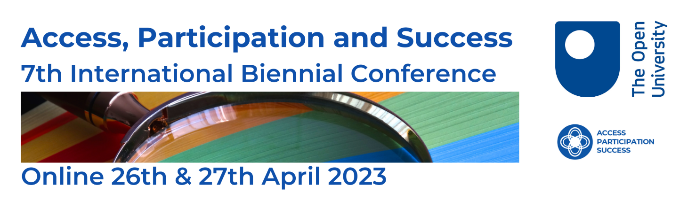

Call for papers / presentations

Through the looking glass: How HE (Higher Education) is using the lens of access, participation and success to create equity for all students

We are pleased to announce that the call for papers for the Open University’s 7th International Biennial Access, Participation and Success Conference is now open.

Our 2023 conference will again be online and free to attend. This format aims to widen attendance from across the UK (United Kingdom) and internationally, and from academics, policy makers, and practitioners at all points in their careers, and very importantly from students. We will be using MS Teams to deliver the conference.

In 2021 more than 600 delegates registered for the conference. In 2023 we aim to exceed this number.

We are seeking papers / presentations from around the globe. The voice of students underrepresented, disadvantaged or discriminated-against in HE is most important. We aim to explore whether the strategic direction and approaches implemented by higher education providers reflect the experiences of students who come from diverse backgrounds. Outcomes of the event will be collated to inform future policy and strategic decisions. A select number will be published in a future edition of the journal Widening Participation and Lifelong Learning. A library of video recordings will be created and accessible publicly after the conference.

Our 4 themed sessions will be:

- Theme 1: Student engagement including co-creation, representation, and student voice
- Theme 2: Inclusion including curriculum, assessment, tuition, and communication
- Theme 3: Accessibility including student support, digital inclusion, and service delivery
- Theme 4: Student outcomes including motivation, equity and employability
We invite papers within these themes reporting innovative approaches to support students underrepresented, disadvantaged or discriminated-against in Higher Education. We recognise that scholarship, research, policy and initiatives in HE will often cross themes. We are particularly keen to receive submissions that combine academic/practitioner research alongside the experiences of students.

The conference will provide a mix of panel discussions, seminars, workshops and keynotes from leading sector practitioners and academics.

How to submit
Please submit details of your proposed contribution using the link at the bottom of this page. Please make sure you follow the criteria below. Submissions will be reviewed by members of the conference steering group. Text included in the abstract must not include any information which identifies the author(s) of the submission or their affiliated organisations.

Seminars (30 minutes)
300 word abstract. Seminars should be an online presentation of 20 minutes, with 10 minutes for Q&A. The conference team will issue guidance on accessibility for presenters if selected.

Workshops (60 minutes)
500 word abstract. Workshops should be aimed at providing an interactive experience for delegates, with some practical outcomes. Submissions should include an overview of the context of the workshop, an indication of format of the workshop including any activities that delegates will undertake and proposed outcomes. Please also indicate if there is an upper limit of delegates for the workshop.

Posters
Submissions for posters must include a brief description (maximum 150 words) of the intended content. Further guidance in relation to the design specification for posters if selected.

Please submit your abstract using this form
Link to Call for Papers Submission Form

Closing date for receipt of abstracts
Friday 2nd December 2022

